S5 Fig: Forest plots of the HR of the combined endpoint in group A (asymptomatic individuals with three or more CVD risk factors) for maximal CCA-IMT with 95% CIs

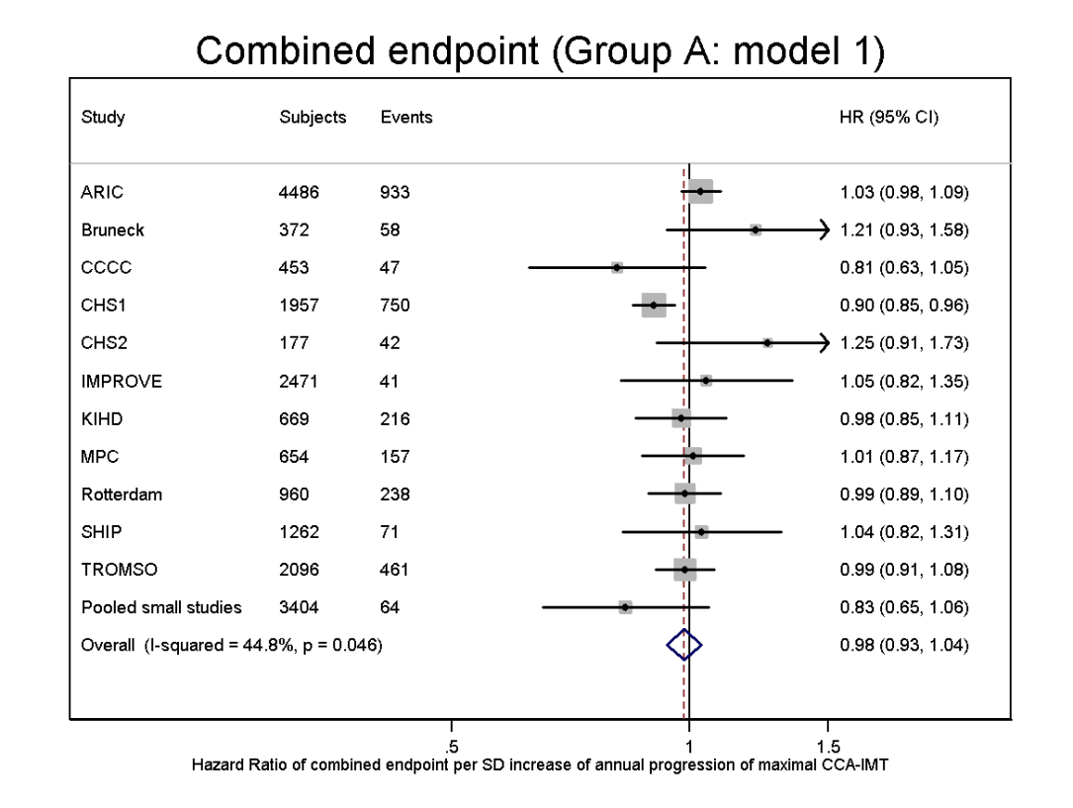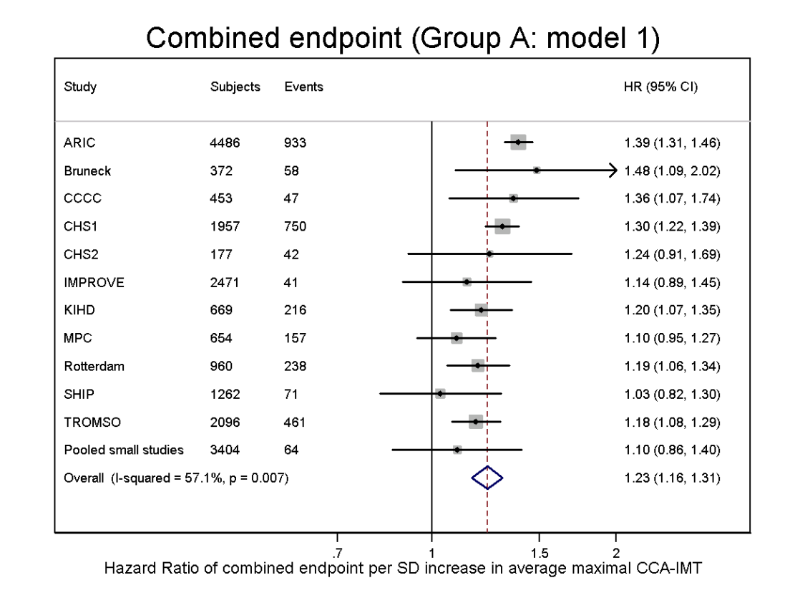
Left panel: HR for the combined endpoint per one SD of annual maximal CCA-IMT change, adjusted for age, sex and average maximal CCA-IMT (model 1)
Right panel: HR for the combined endpoint per one SD of average maximal CCA-IMT, adjusted for age, sex and annual maximal CCA-IMT change (model 1)

