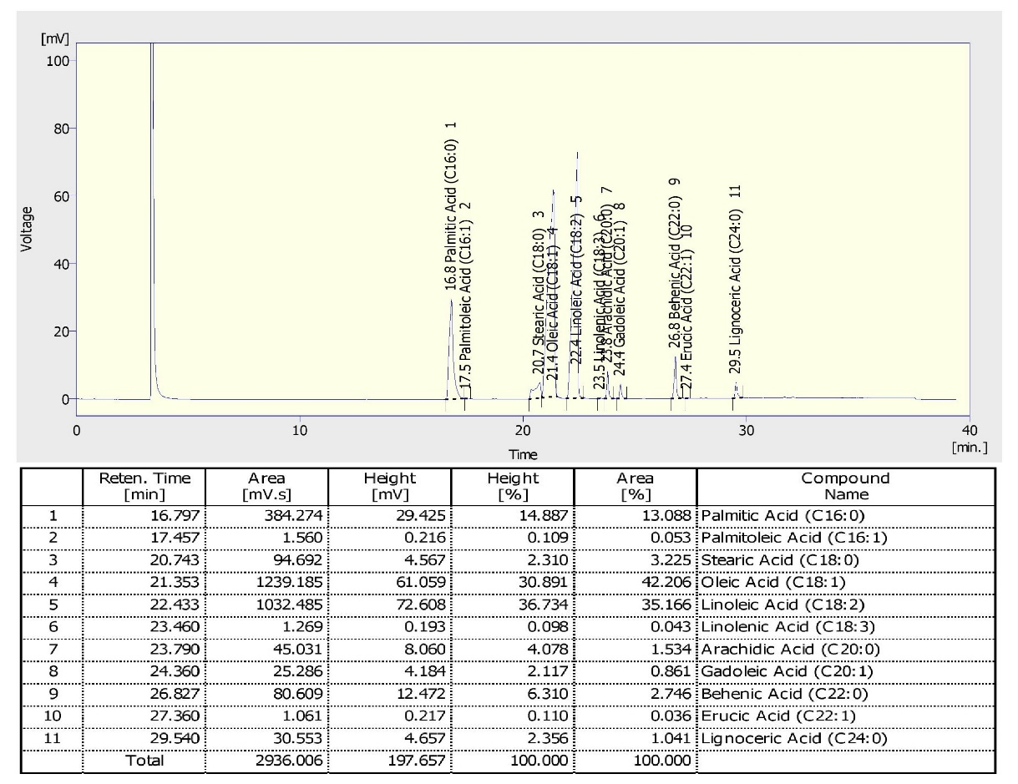
Fatty acid profile of ICGV06100 planted in ICAR-DGR during 2014 post rainy season
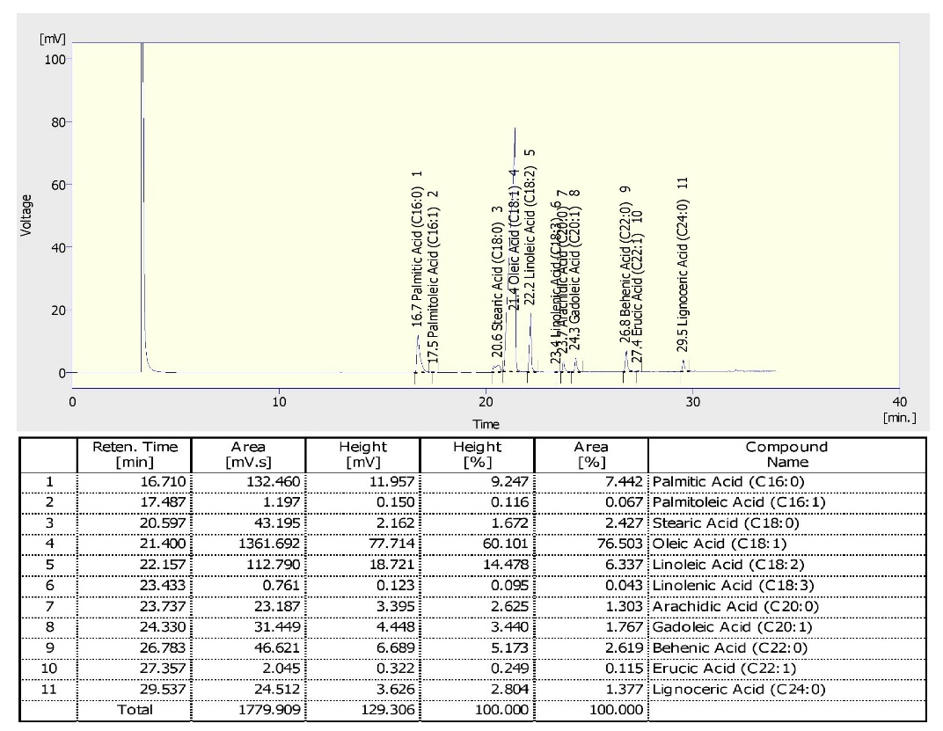
Fatty acid profile of SunOleic95R planted in ICAR-DGR during 2014 post rainy season
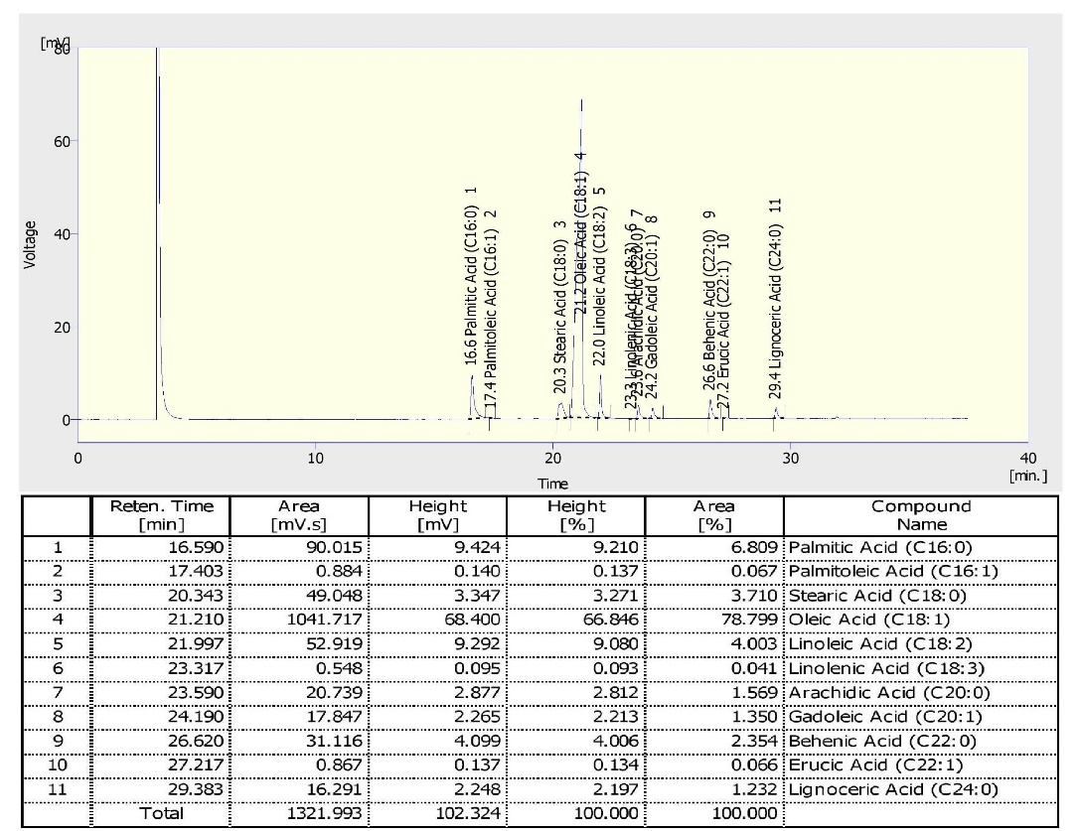
Fatty acid profile of NRCGCS-587 planted in ICAR-DGR during 2014 post rainy season
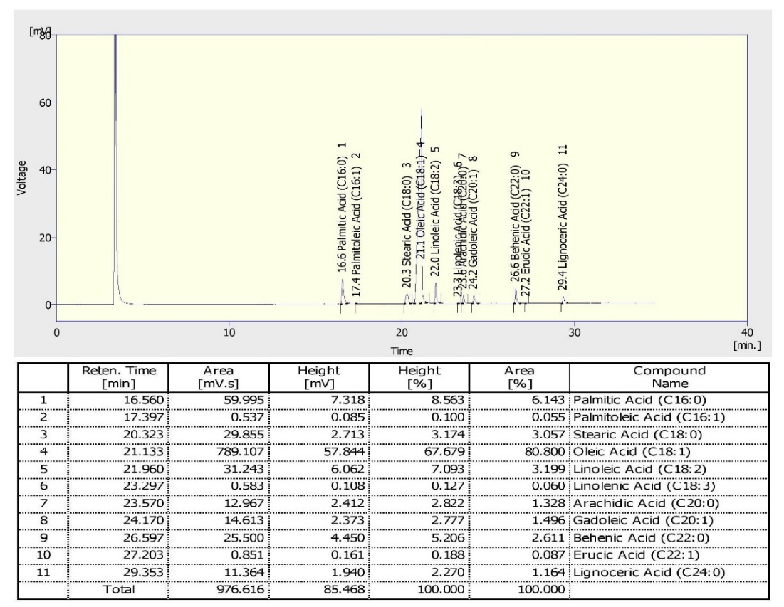
Fatty acid profile of NRCGCS-587 planted in ICAR-DGR during 2015 rainy season
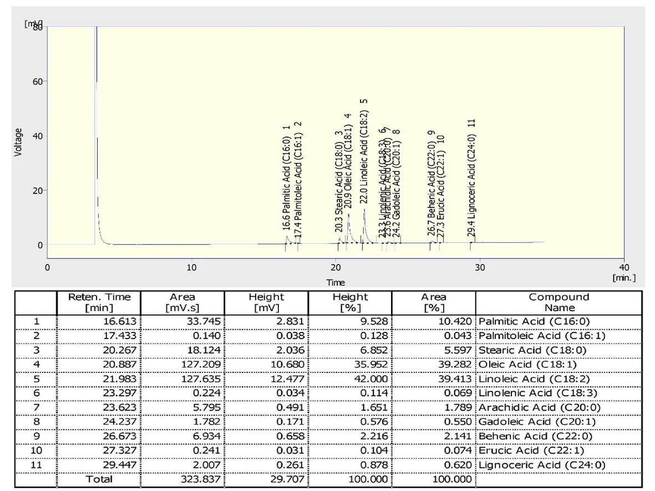
Fatty acid profile of ICGV06100 planted in ICAR-DGR during 2016 rainy season
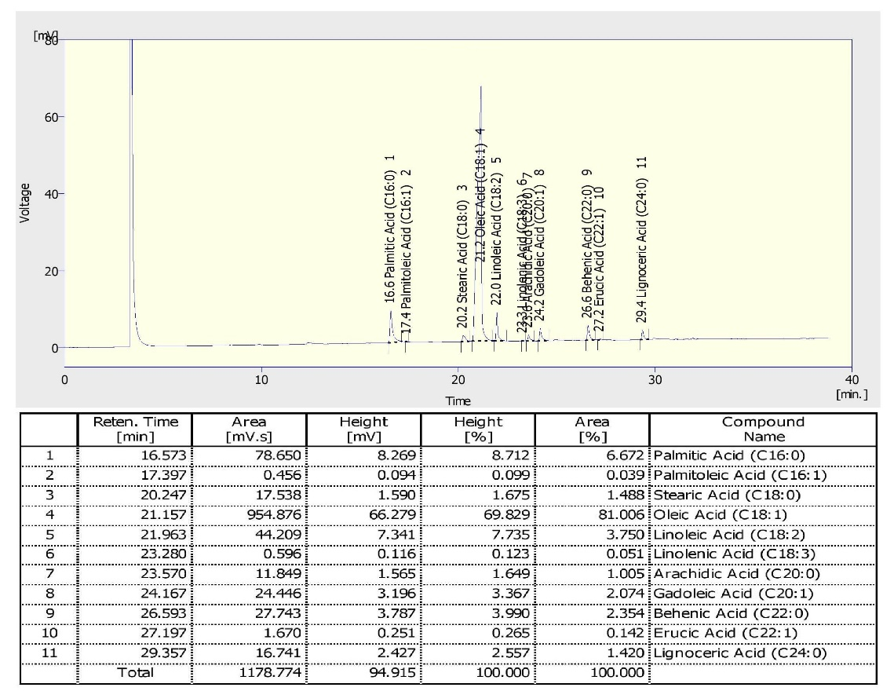
Fatty acid profile of SunOleic95R planted in ICAR-DGR during 2016 rainy season
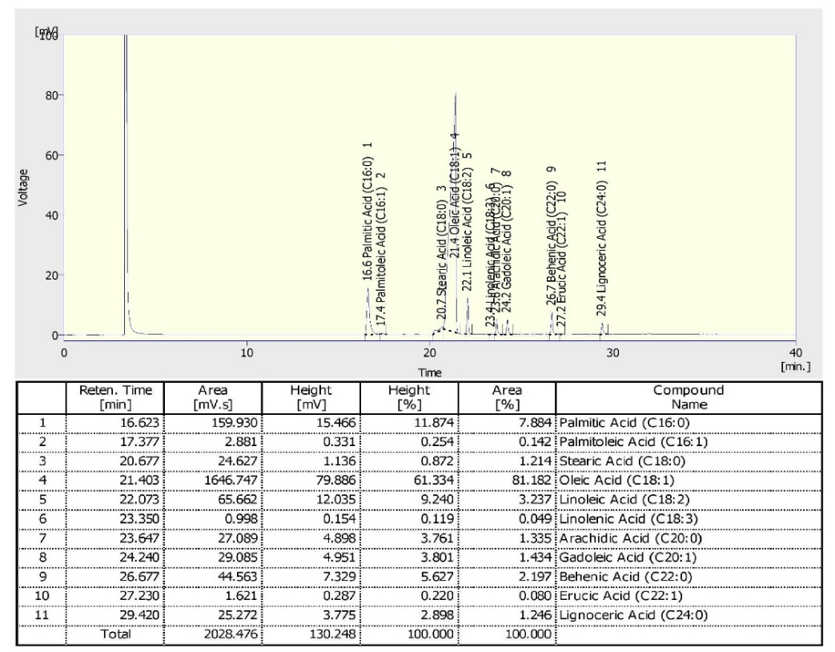
Fatty acid profile of NRCGCS-587 grown in ICAR-DGR, Junagadh during 2016 rainy season
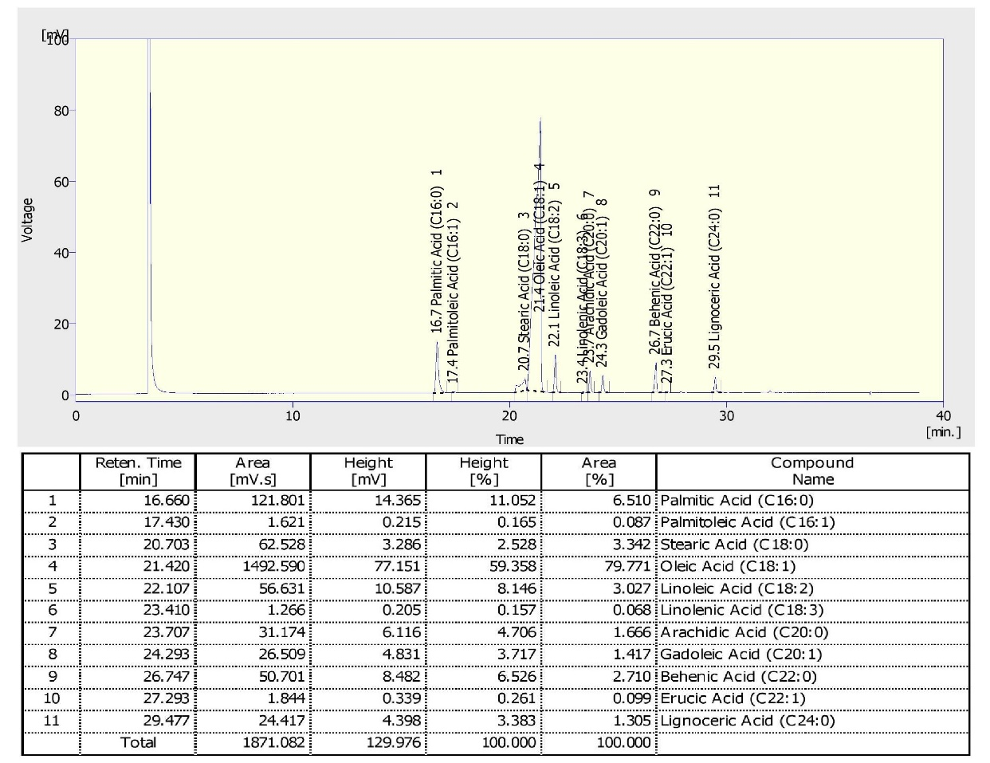
Fatty acid profile of NRCGCS-587 grown in ICRISAT, Telegana during 2016 rainy season
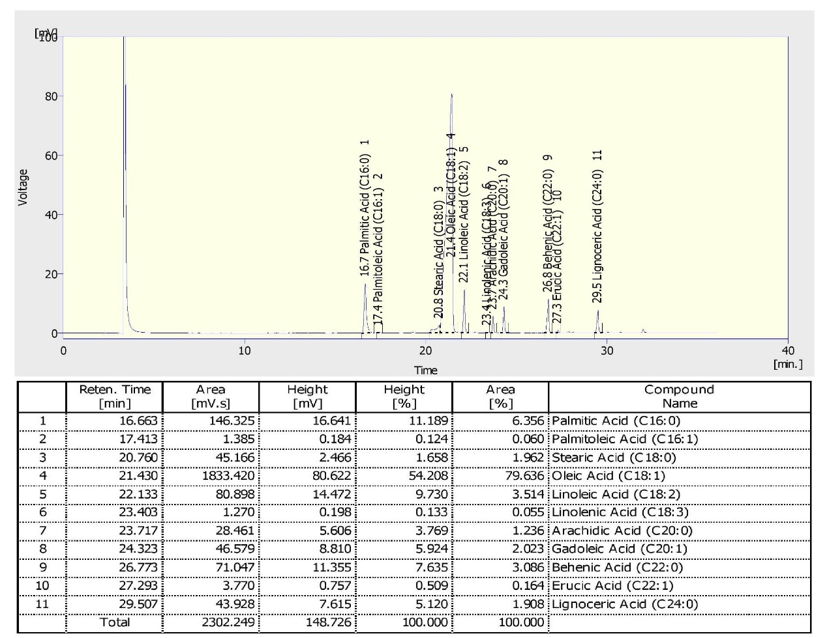
Fatty acid profile of NRCGCS-587 grown in RARS, ANGRAU, Tirupati, Andhra Pradesh during 2016 rainy season

