**S2 Fig.** **LD plots for CEU, Asians and Yoruba (YRI) based on HapMAP version 3.**

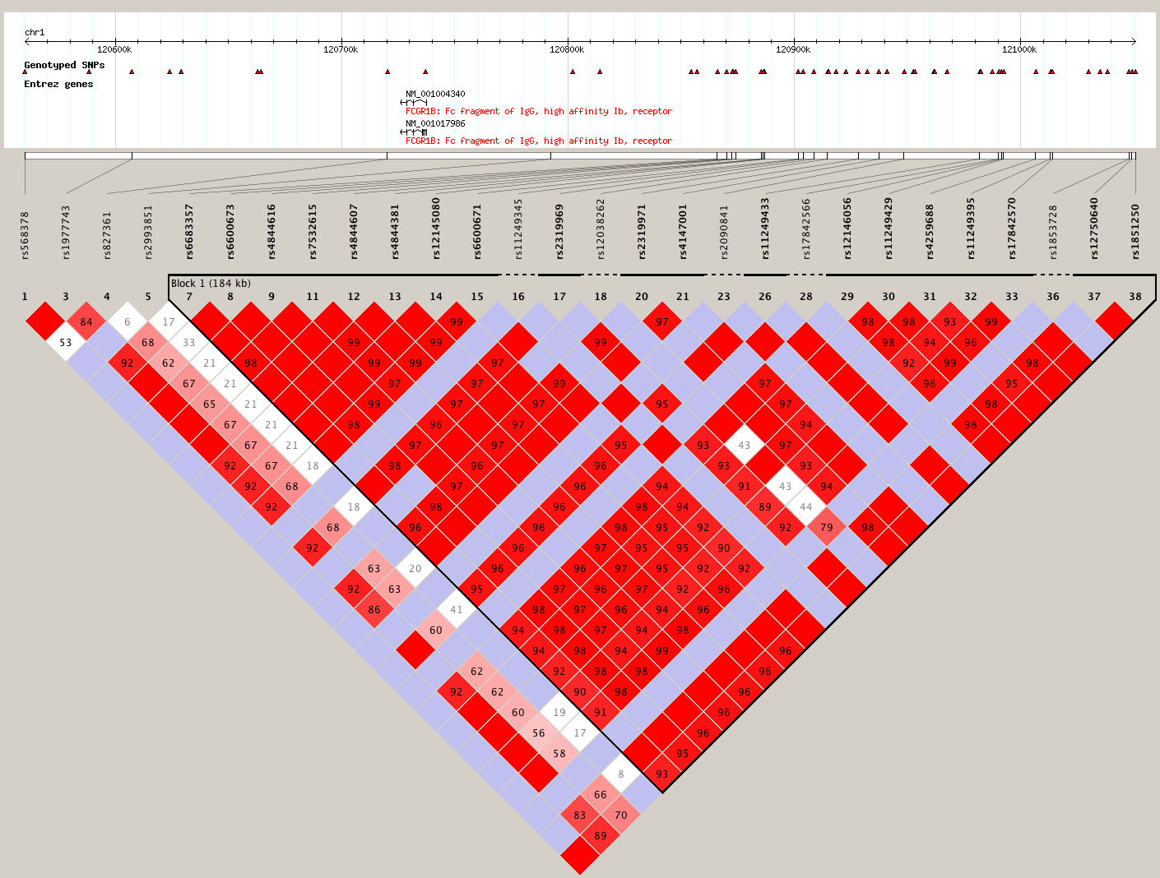

CEU

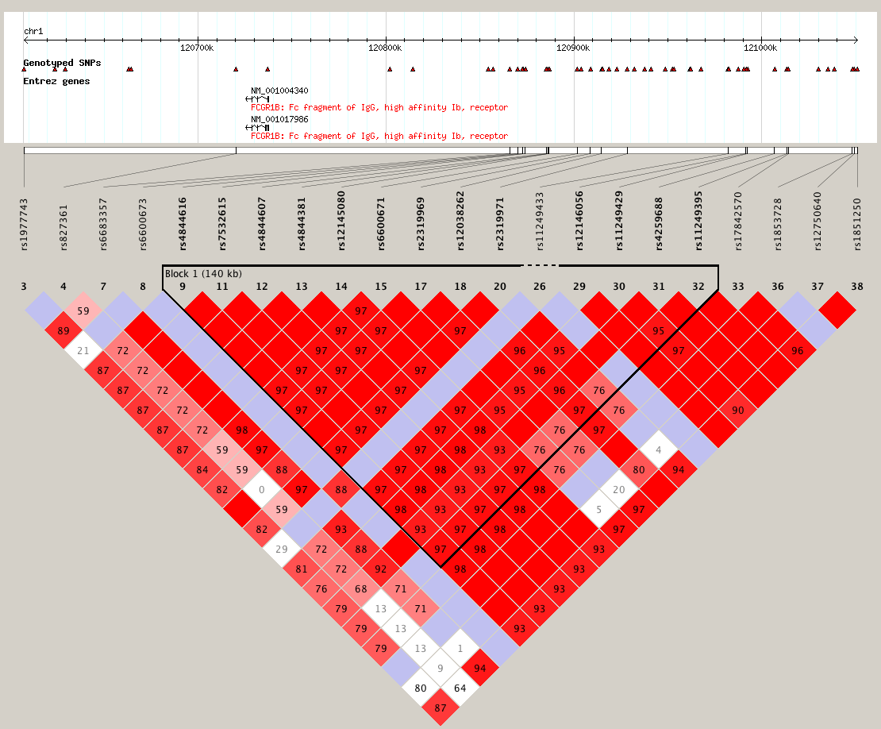

Asians

YRI

