S6 Fig: Meta-regression plots for the HR (combined endpoint) per SD of annual mean CCA-IMT change, by the year of the study start for group A cohorts. The size of each circle represents the precision of the log HR.

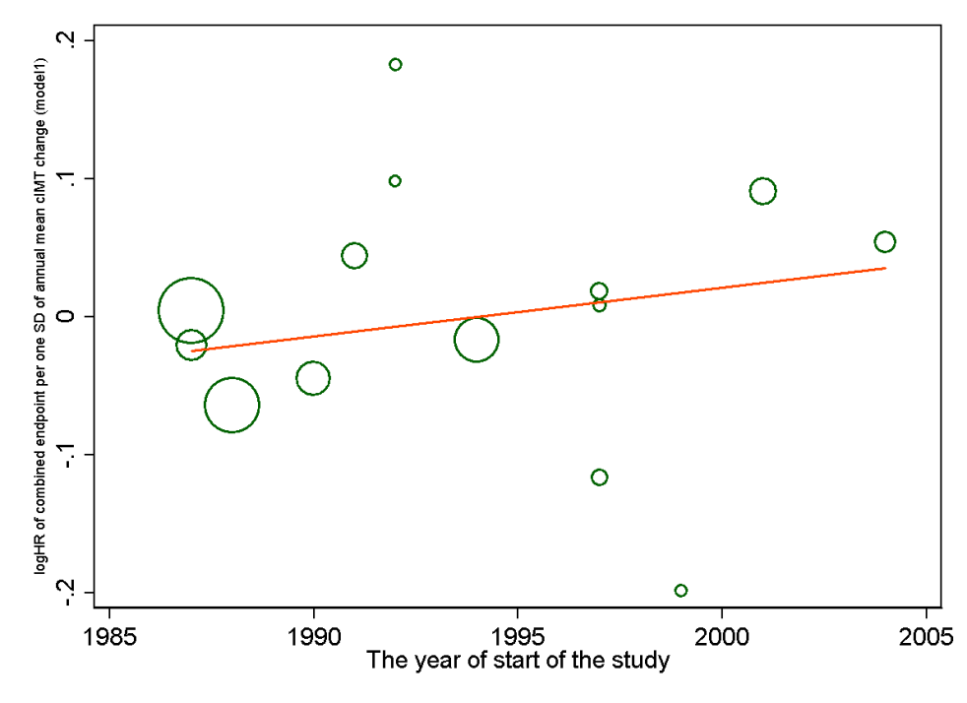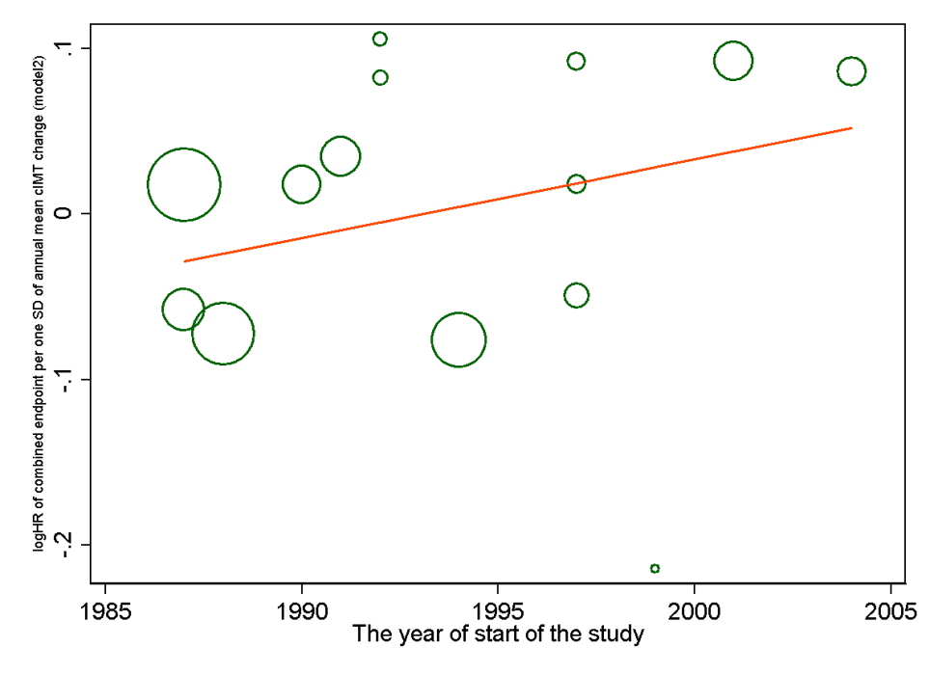
Left panel: Model 1 (HR adjusted for age, sex, and average mean CCA-IMT): weighted regression line y=7.07+0.004*x (p=0.34)
Right panel: Model 2 (HR adjusted for age, sex, average mean CCA-IMT and other CVD risk factors): weighted regression line y=-9.43+0.005*x (p=0.32)

