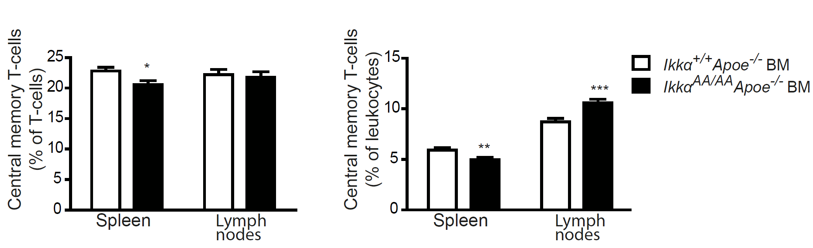
Figure S3. Effect of a bone marrow-specific Ikkα^{AA/AA} knock-in on central memory T-cells. Shown is flow cytometric analysis of Cd44^{high}Cd62L^{high} central memory T-cells in spleen and lymph nodes from Apoe^{-/-} mice transplanted with Ikkα^{AA/AA}Apoe^{-/-} or Ikkα^{+/+}Apoe^{-/-} BM and receiving a high-cholesterol diet for 13 weeks. Data are represented as percentage of Cd3⁺ T-cells (left) and as percentage of Cd45⁺ leukocytes (right). Graphs represent the mean ± SEM (n=18-19), 2-tailed t-test, *P<0.05, **P<0.01, ***P<0.001.

