Natural Cellulose Nanofibers as Sustainable Enhancers in Construction Cement
Supporting Information

Table A. Compositions of cement
CaO | MgO | Fe₂O₃ | Al₂O₃ | SiO₂ | K₂O | Na₂O | SO₃ | P₂O₅ | MnO | TiO₂ | LOI | Blaine fineness
54.6305 | 3.2725 | 2.9167 | 6.6034 | 24.061 | 0.5617 | 0.1205 | 2.7257 | 0.0795 | 0.8466 | 0.4244 | 3.05 | 365

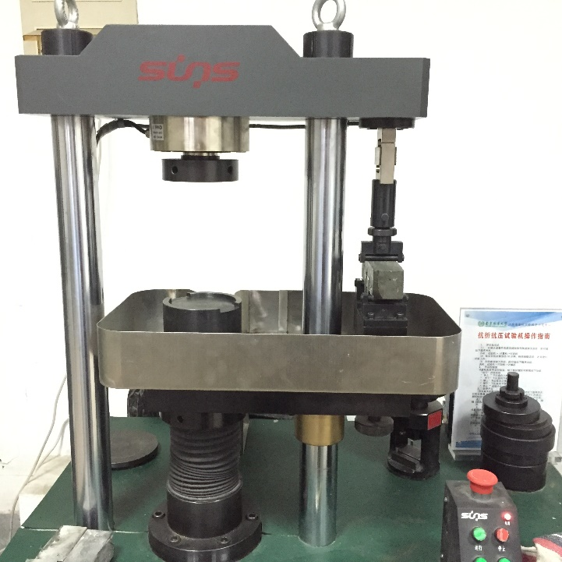
Fig A. The images for testing the flexural strength and compressive strength

