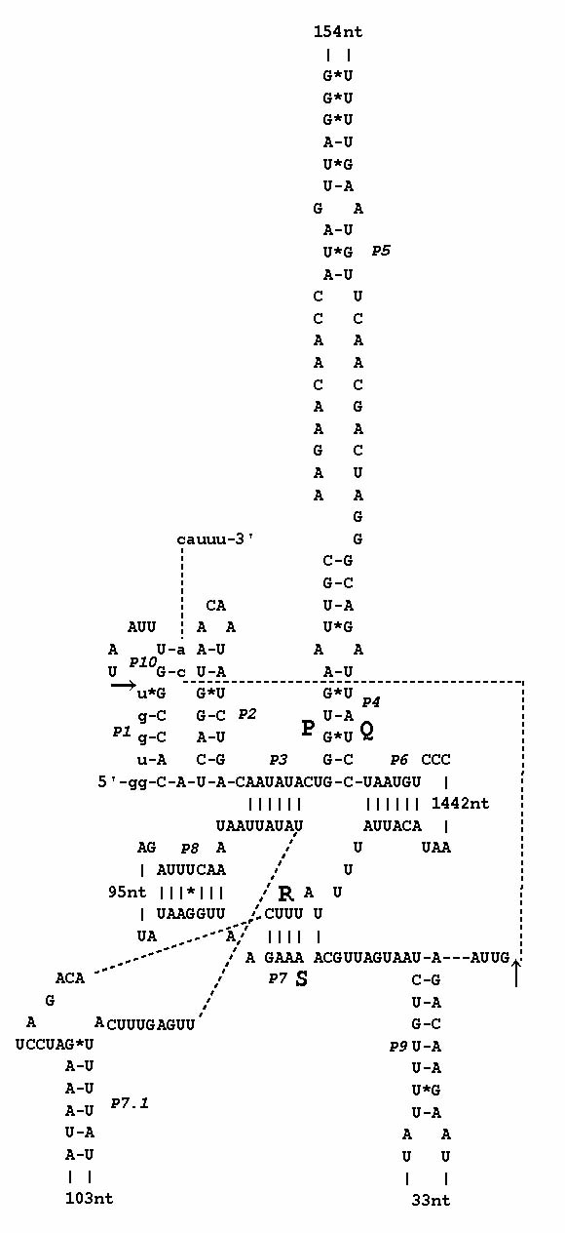

S3 Fig. Secondary structure map of possible group IA intron inserted in psbC gene of Volvox sp. Sagami.

