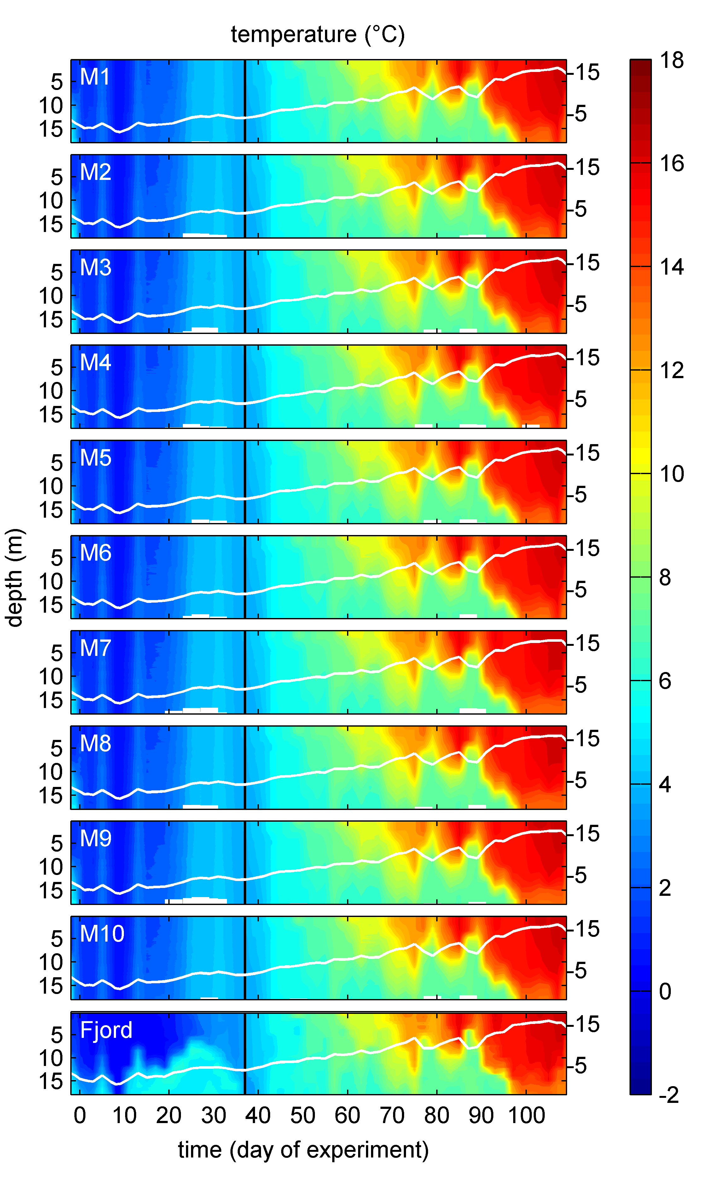
S3 Fig. Temperature profiles over the course of the study. Changes in temperature averaged over the entire water column are represented by the white line plots on top of the contours with the corresponding y-axes on the right side. The black lines at t37 mark the end of convective mixing (See also Fig 5).

