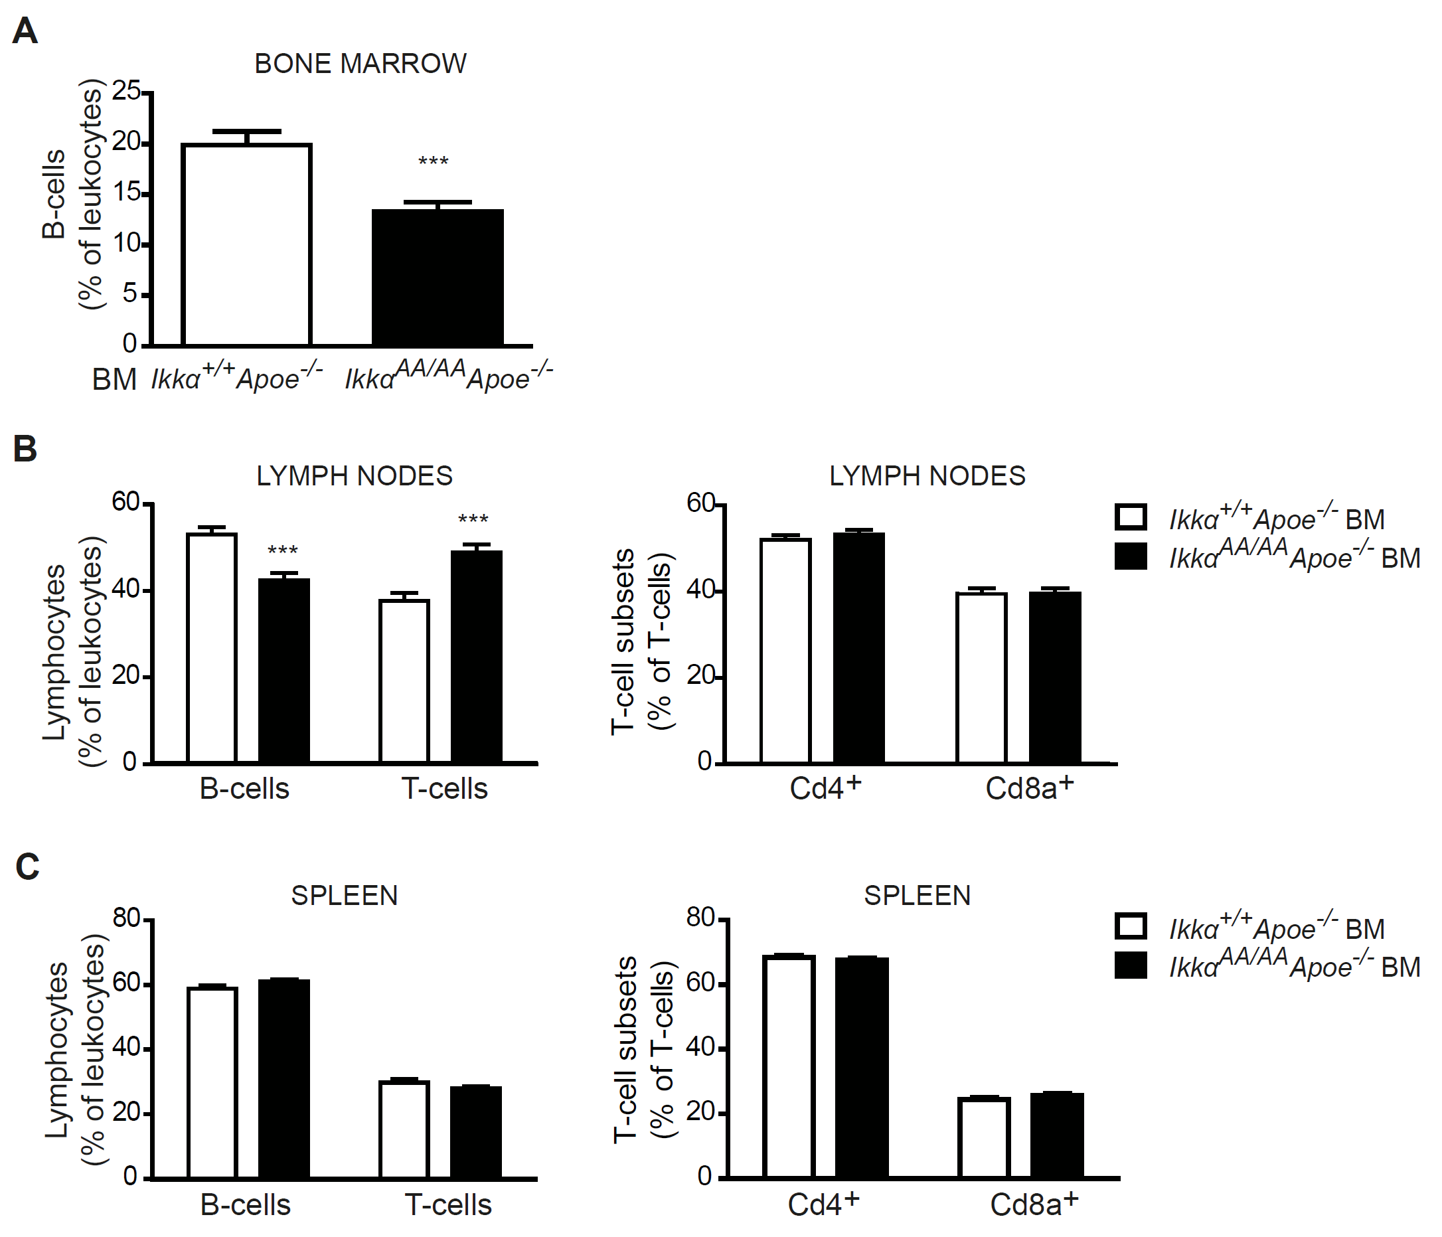
Figure S1. Effect of a bone marrow-specific Ikkα^{AA/AA} knock-in on B- and T-cell populations in bone marrow and secondary lymphoid organs. Shown is flow cytometric analysis of bone marrow, spleen and lymph nodes from Apoe^{-/-} mice transplanted with Ikkα^{AA/AA}Apoe^{-/-} or Ikkα^{+/+}Apoe^{-/-} BM and receiving a high-cholesterol diet for 13 weeks. (A) Cd19⁺ B-cell population as percentage of Cd45⁺ leukocytes. (B-C) Cd19⁺ B-cell and Cd3⁺ T-cell populations as percentage of Cd45⁺ leukocytes, and Cd4⁺ and Cd8a⁺ T-cell subsets as percentage of Cd3⁺ T-cells in lymph nodes (B) and spleen (C). All graphs represent the mean ± SEM (n=18-19), 2-tailed t-test, ***P<0.001.

