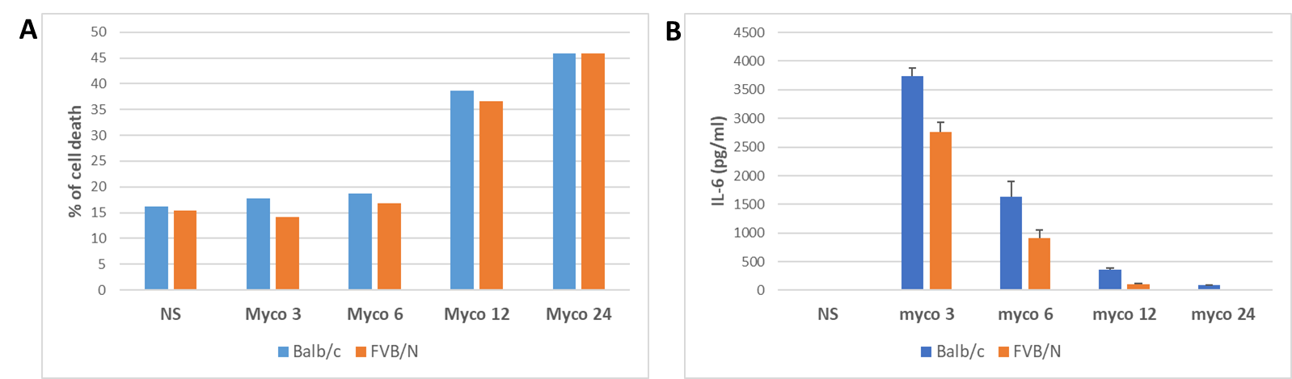

Figure S1 : Quantification of toxicity and IL-6 secretion in a dose-response of mycolactone on FVB/N and Balb/c macrophages.
A. BMDM cells were stimulated with mycolactone at dose of 3, 6 or 12 or 24 ng/ml during 48h. Cytotoxic effect was recorded using ToxiLight bioassay kit (Lonza). B. IL-6 were detected in supernatant of cells by ELISA at 48h post-stimulation with NPM.

