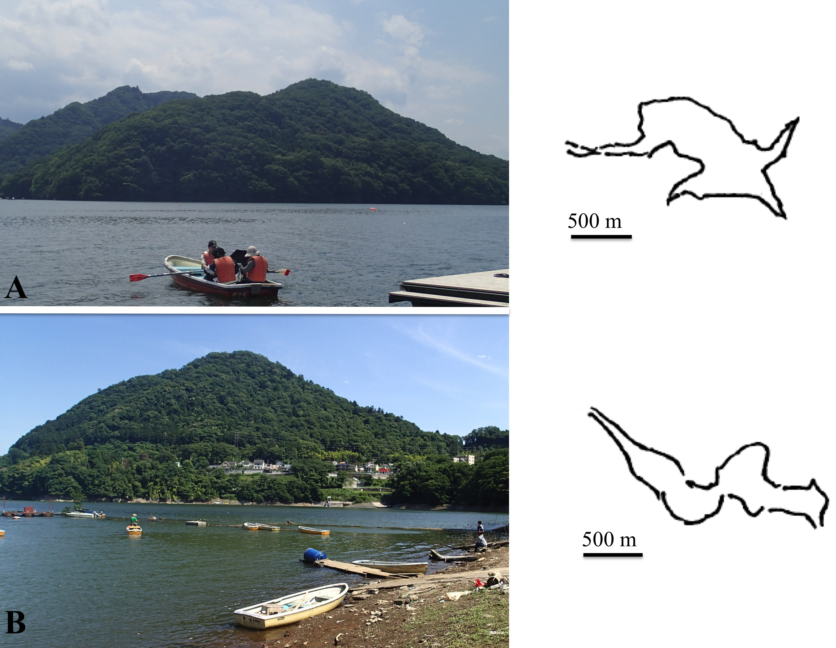
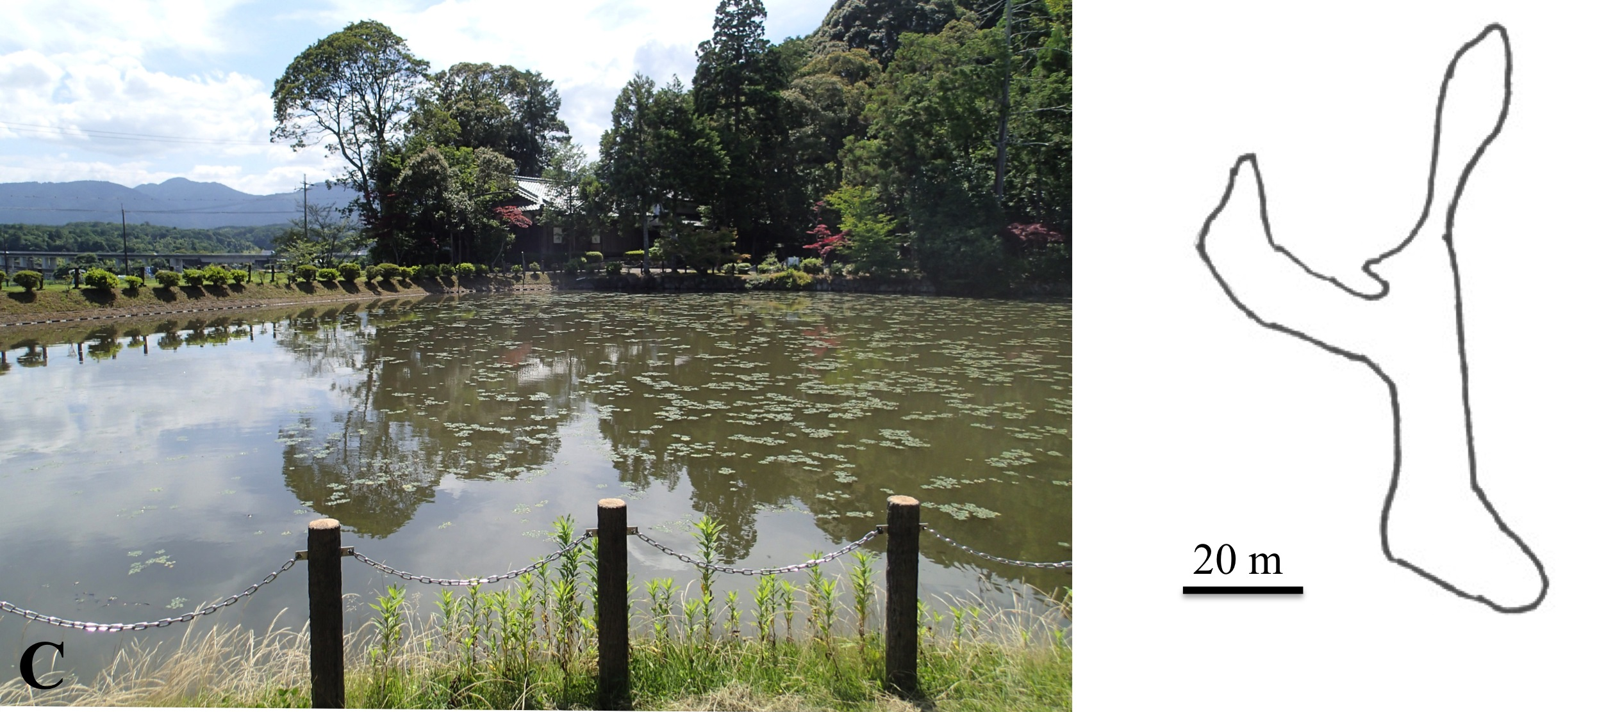

S1 Fig. Two large lakes and a pond from which Volvox sp. Sagami was collected in Japan. Original photographs and drawings. A. Lake Sagami (S1 and S3 Tables). B. Lake Tsukui (S1 and S3 Tables). C. Miyaike pond (S1 and S3 Tables).

