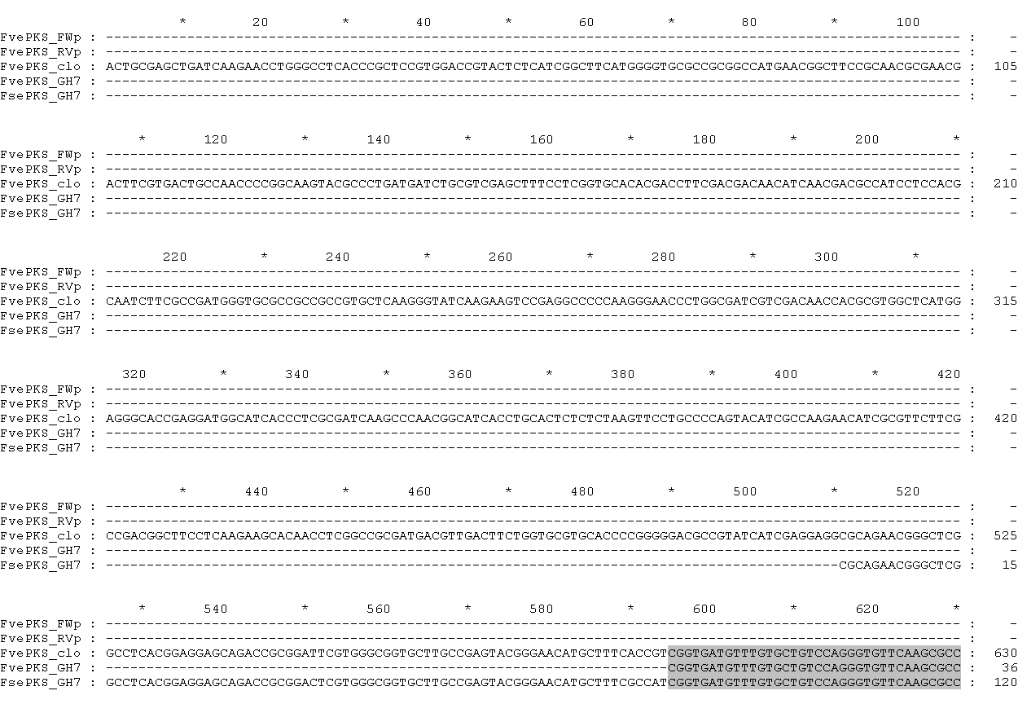
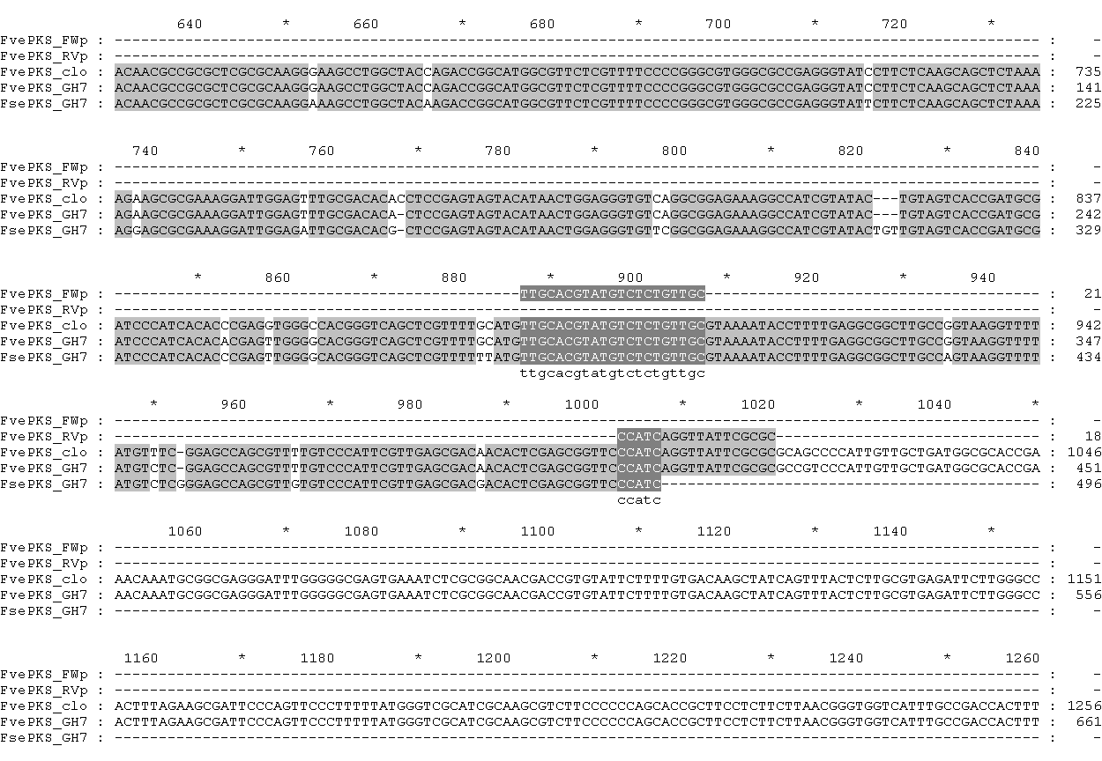
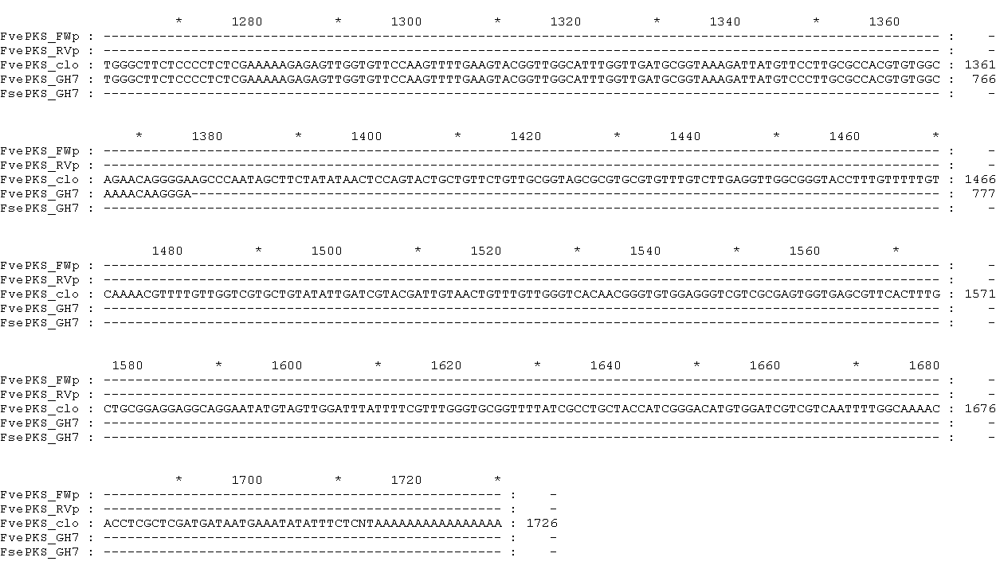
S1 Fig.A: Nucleotide alignment of the brown algal PKS III coding sequences.
Nucleotide alignment of the Fucus vesiculosus cDNA sequence with Fucus EST sequences.
qPCR forward primer (FvePKS_FWp), qPCR reverse primer (FvePKS_RVp), partial cDNA sequence cloned from F. vesiculosus (FvePKS_clo), F. vesiculosus EST of GH706741 GenBank accession (FvePKS_GH7), F. serratus EST of GH701018 GenBank accession (FsePKS_GH7). The positions sharing a conservation of 100, 80 and 60% are respectively shaded in black, dark grey and light grey.

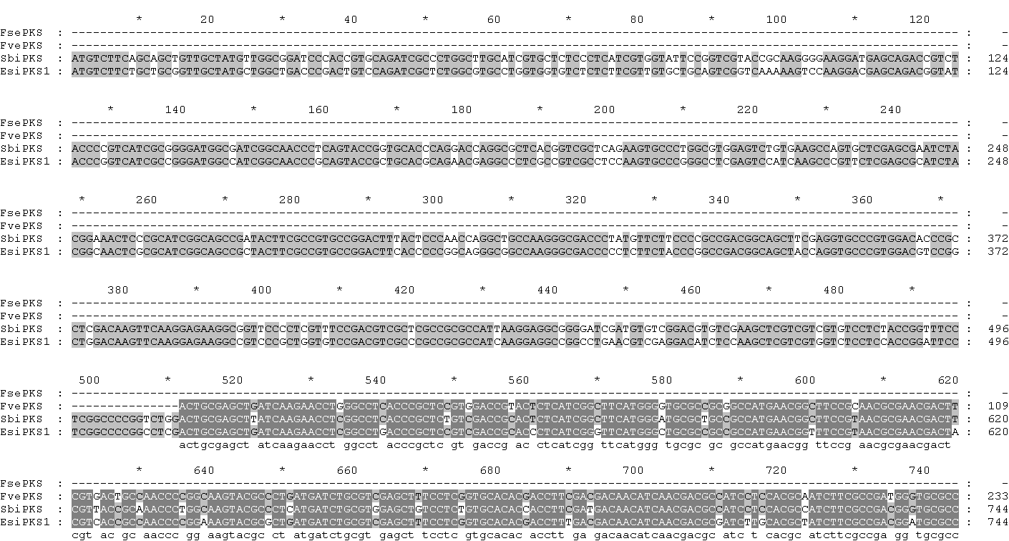

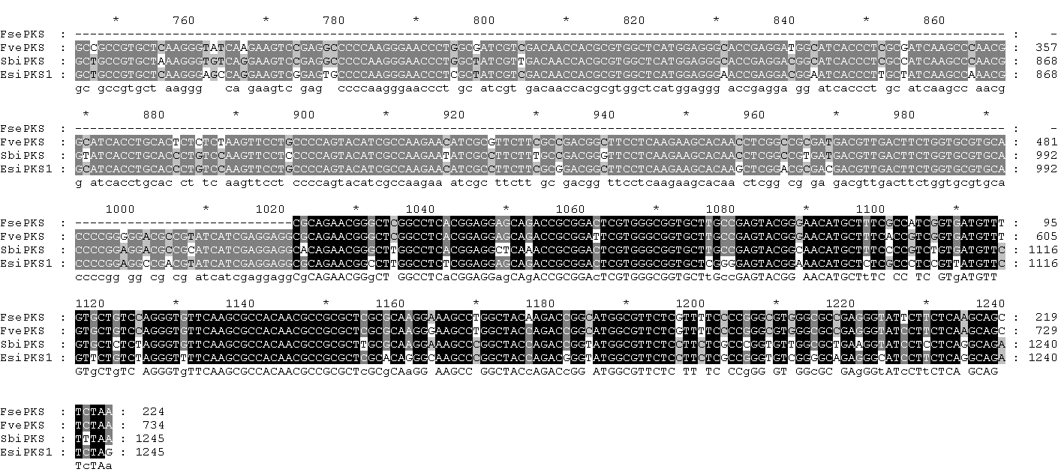
S1 Fig. B: Nucleotide alignment of the brown algal PKS III coding sequences.
Fucus serratus GH701018 (FsePKS), partial cDNA sequence cloned from Fucus vesiculosus (FvePKS), Sargassum binderi HM245964 (SbiPKS), Ectocarpus siliculosus Esi0024_0032 ORCAE Id (EsiPKS1). The positions sharing a conservation of 100, 75 and 50% are respectively shaded in black, dark grey and light grey.

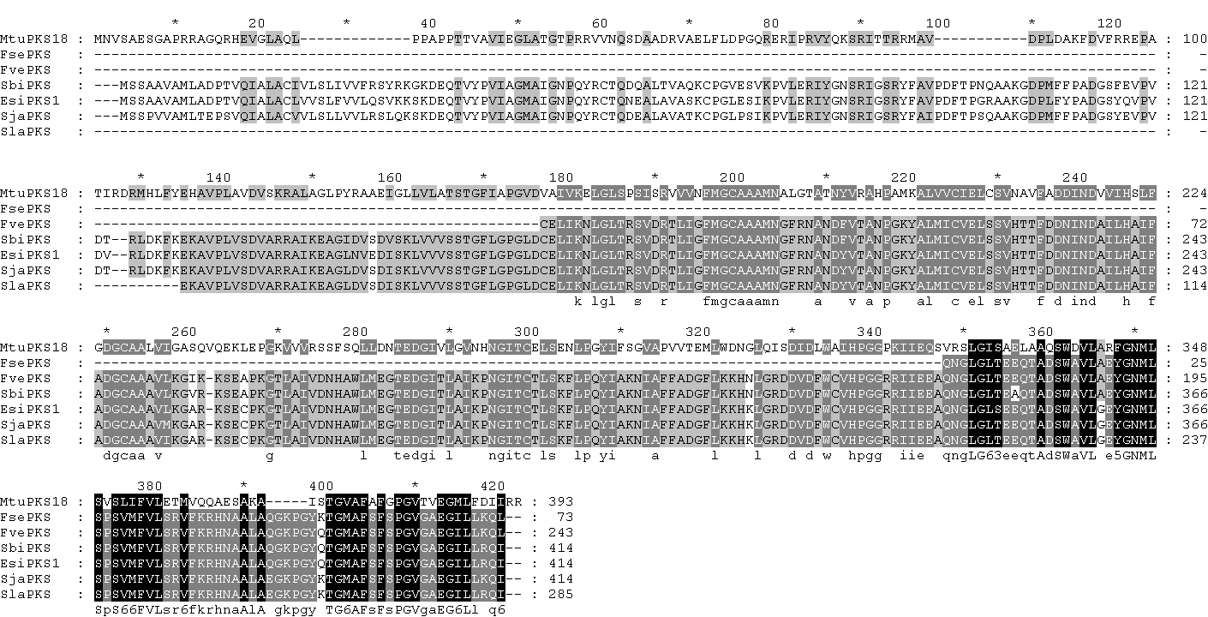
S1 Fig.C: Protein sequence alignment of the brown algal PKS III with a bacterial counterpart.
Mycobacterium tuberculosis P9WPF0 (MtuPKS18), translated sequence of Fucus serratus GH701018 (FsePKS), translated sequence of Fucus vesiculosus (FvePKS), Sargassum binderi ADK13089 (SbiPKS), Ectocarpus siliculosus Esi0024_0032 (EsiPKS1), translated sequence of Saccharina japonica contig_6991 (SjaPKS), translated sequence of Saccharina latissima contig_4304 (SjaPKS). The residues sharing 100, 80 and 60% identity are respectively shaded in black, dark grey and light grey.

