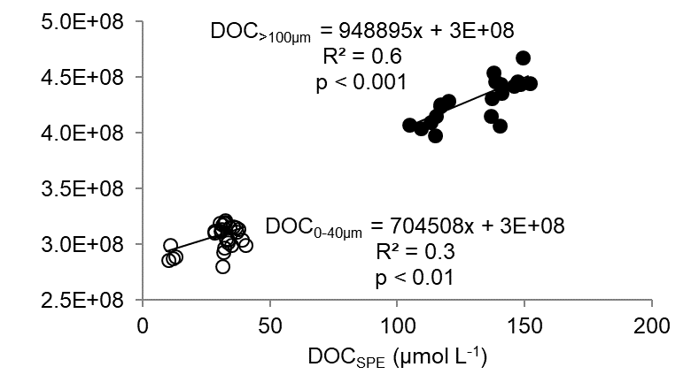
S1 Fig. UV peak area at 210 nm versus DOC_{SPE} concentrations of all samples. A significant linear correlation was found for both fractions: the low concentrated fraction (all pH 8 extracted samples and the pH 2 extracted marine sample) with DOC_{SPE} concentrations from 0 – 40 µmol L⁻¹ (unfilled symbols) and the high concentrated fractions (pH 2 extracted riverine and estuarine samples) with DOC_{SPE} concentrations > 100 µmol L⁻¹ (filled symbols).

